

Computer Engineering Department
Course name: Web Technologies
Course code: 2CP08
Faculty: Prof Kirtikumar Sharma

ID: 23CP029
Name: Viral Vipulkumar Bhoi
Topic: Report of LAB - 6

LAB 6: JavaScript: use of document.writeln(), comments, variables, local vs Global, type of operators, arithmetic, assignment, relational, logical & Bitwise Operators, Control structures, conditional statements, array, user define function, object, use if For/in

TABLE OF CONTENT:

6.1 Brief introduction of used JS . . . . . . . . . . . . . . . . . . . . . . . . . . . . . . . . . . . . . . . . . . . . . . . . 3
6.2 Exercise 1 . . . . . . . . . . . . . . . . . . . . . . . . . . . . . . . . . . . . . . . . . . . . . . . . . . . . . . . . . . . . . . . 4
6.3 Exercise 2 . . . . . . . . . . . . . . . . . . . . . . . . . . . . . . . . . . . . . . . . . . . . . . . . . . . . . . . . . . . . . . . 7
6.4 Exercise 3 . . . . . . . . . . . . . . . . . . . . . . . . . . . . . . . . . . . . . . . . . . . . . . . . . . . . . . . . . . . . . . . 8
6.5 Exercise 4 . . . . . . . . . . . . . . . . . . . . . . . . . . . . . . . . . . . . . . . . . . . . . . . . . . . . . . . . . . . . . . . 11
6.6 Exercise 5 . . . . . . . . . . . . . . . . . . . . . . . . . . . . . . . . . . . . . . . . . . . . . . . . . . . . . . . . . . . . . . . 13
6.7 Exercise 6 . . . . . . . . . . . . . . . . . . . . . . . . . . . . . . . . . . . . . . . . . . . . . . . . . . . . . . . . . . . . . . . 14

6.1 Brief introduction of used JS::

- JavaScript:
  - JavaScript is a programming language that makes web pages interactive.
  - Some main function of JS: User-side calculations, User input validation, Dynamic websites, Handling API calls, Interacting with databases, Real-time updates, Animations & UI effects.
- var:
  - Function-scoped, can be redeclared and updated.
- let:
  - Block-scoped, cannot be redeclared but can be updated.
- const:
  - Block-scoped, cannot be redeclared or updated.
- comments:
  - Single-line comment // This is a comment.
  - Multi-line comment /* This is a multi-line comment */.
- Local Variable:
  - Declared inside a function/block, accessible only within it.
- Global Variable:
  - Declared outside any function, accessible everywhere.
- Types of operators:
  - Arithmetic Operators → + - * / % ** ++ -- .
  - Assignment Operators → = += -= *= /= %= **=
  - Relational Operators → == === != !== > < >= <=
  - Logical Operators → && (AND) || (OR) ! (NOT)
  - Bitwise Operators → & | ^ ~ << >> >>>
- Control Structures:
  - Conditional Statements → Execute code based on conditions (if-else, switch).
    - switch(){
case:
default:
}
    - if(condition){
}
else{
}
  - Loops → Repeat code execution (for, while, do-while).
    - do{
}while(condition);
    - while(condition){
}
    - for(condition){
}
- User Defined Functions:
  - A user-defined function is a function created by the user to perform a specific task.
    - function function_name (parameters) {
// function body
return return_value;
}
- Objects:
  - An object is a collection of key-value pairs where values can be of any data type.
    - Let obj_name = {
key: value;
}

6.2 Exercise 1: Write a JavaScript program to use Operators

HTML:

<!DOCTYPE html>
<html lang="en">
<head>
<meta charset="UTF-8">
<meta name="viewport" content="width=device-width, initial-scale=1.0">
<title>Document</title>
</head>
<body>
<script>
let a= 2+3;
document.writeln("2+3 = ",a," ", typeof(a),"<br>");
a = 2 +"MB";
document.writeln('2 + "MB" = ',a," ", typeof(a),"<br>");
a= "hello" + "bvm";
document.writeln('"hello" + "bvm" = ',a," ", typeof(a),"<br>");
a = 3 - 2;
document.writeln("3-2 = ",a," ", typeof(a),"<br>");
a = 3 -"MB";
document.writeln('3-"MB" = ',a," ", typeof(a),"<br>");
a = 3*2;
document.writeln('3*2 = ',a," ", typeof(a),"<br>");
a = 5/2;
document.writeln('5/2 = ',a," ", typeof(a),"<br>");
a = 2/0;
document.writeln('2/0 = ',a," ", typeof(a),"<br>");
a = 5%2;
document.writeln('5%2 = ',a," ", typeof(a),"<br>");
a = 2%0;
document.writeln('2%0 = ',a," ", typeof(a),"<br>");
let x = 1;
document.writeln("x = ", x," ", typeof(x),"<br>");
x++;
document.writeln("x++ =", x," ", typeof(x),"<br>");
let y = ++x
document.writeln("y = ++x, y=", y," ","x=",x," ", typeof(y),"<br>");
y = x++
document.writeln("y = x++, y=", y," ","x=",x," ", typeof(y),"<br>");
x = 5;
document.writeln("x = ", x," ", typeof(x),"<br>");
x--;
document.writeln("x-- =", x," ", typeof(x),"<br>");
y = --x
document.writeln("y = --x, y=", y," ","x=",x," ", typeof(y),"<br>");
y = x--
document.writeln("y = x--, y=", y," ","x=",x," ", typeof(y),"<br>");
</script>
</body>
</html>

OUTPUT:

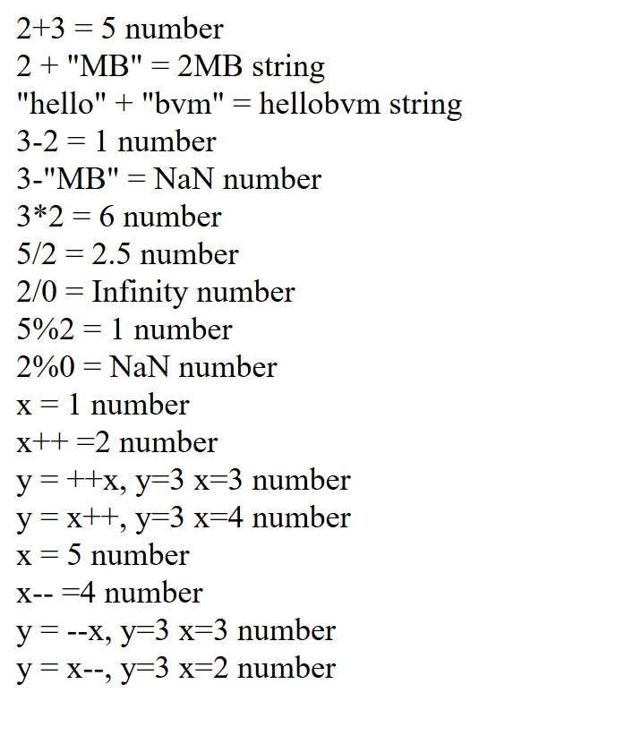

6.3 Exercise 2: Write a JavaScript program to use bitwise Operators.

HTML:

<!DOCTYPE html>
<html lang="en">
<head>
<meta charset="UTF-8">
<meta name="viewport" content="width=device-width, initial-scale=1.0">
<title>Document</title>
</head>
<body>
<script>
let a = 5, b=2;
document.writeln("5 | 2 = ",a|b, "<br>");
document.writeln("5 & 2 = ",a&b, "<br>");
document.writeln("5 ^ 2 = ",a^b, "<br>");
document.writeln("!5 = ",!a, "<br>");
document.writeln("!0 = ", !0 , "<br>");
document.writeln("~0 = ", ~0 , "<br>");
document.writeln("~5 = ", ~5 , "<br>");
document.writeln("~2 = ", ~2 , "<br>");
document.writeln("5 << 2 = ", a<<b , "<br>");
document.writeln("5 >> 1 = ", 5>>1 , "<br>");
document.writeln("1 << 5 = ", 1<<5 , "<br>");
document.writeln("32 >> 2 = ", 32>>2 , "<br>");
</script>
</body>
</html>

OUTPUT:
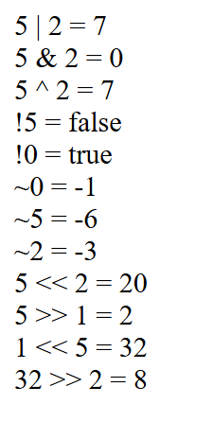

6.4 Exercise 3:Write a JavaScript program to dipsy first N Fibonacci number .

HTML:

<!DOCTYPE html>
<html lang="en">
<head>
<meta charset="UTF-8">
<meta name="viewport" content="width=device-width, initial-scale=1.0">
<title>Document</title>
</head>
<body>
<script>
let a=0;
let b=1;
let n = Number(prompt("How many terms You want to print : "));
for(let i=1;i<=n;i++){
if(i==1){
document.writeln("term no. ",i," = ",a,"<br>");
}else if(i == 2){
document.writeln("term no. ",i," = ",b,"<br>");
}else{
let temp = a+b;
a = b;
b = temp;
document.writeln("term no. ",i," = ",b,"<br>");
}
}
</script>
</body>
</html>

OUTPUT:

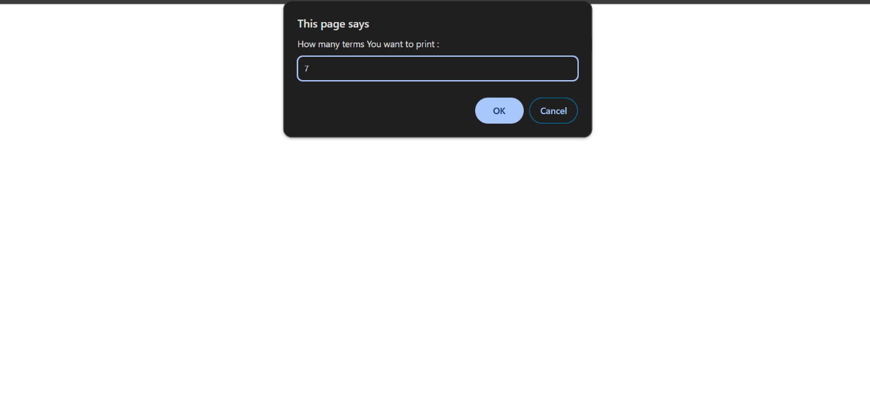
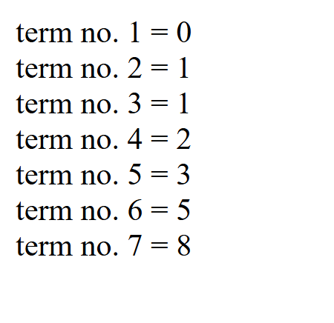

6.5 Exercise 4: Write JavaScript to finding all the prime number between user give ranges

HTML:

<!DOCTYPE html>
<html lang="en">
<head>
<meta charset="UTF-8">
<meta name="viewport" content="width=device-width, initial-scale=1.0">
<title>Document</title>
</head>
<body>
<script>
let first = Number(prompt("Enter lower limit"));
let last = Number(prompt("Enter Upper limit"));

function isPrime(num){
if(num == 1){
return false
}else if(num ==2){
return true;
}

for(let i=2; i<= Math.sqrt(num);i++){
if(num % i == 0){
return false;
}
}

return true;
}

for(let i=first;i<=last;i++){
if(isPrime(i)){
document.writeln("prime = ",i,"<br>");
}
}
</script>
</body>
</html>

OUTPUT:
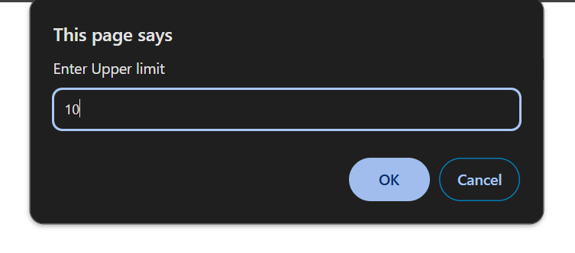

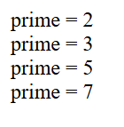
6.6 Exercise 5: Write JavaScript to use arrays methods e.g. reverse, concat, sort, join.

HTML:

<!DOCTYPE html>
<html lang="en">
<head>
<meta charset="UTF-8">
<meta name="viewport" content="width=device-width, initial-scale=1.0">
<title>Document</title>
</head>
<body>
<script>
let arr = [1,2,4,2,3,5,3,1,4,3,2];
document.writeln(" Arr = ");
for( a of arr){
document.write(a," ");
}
arr.reverse();
document.writeln("<br>");
document.writeln("reversed array = ");
for( a of arr){
document.write(a," ");
}
arr.sort();
document.writeln("<br>");
document.writeln("sorted array = ");
for( a of arr){
document.write(a," ");
}
document.writeln("<br>");
document.writeln(arr.join(" --> "))
document.writeln("<br>");
document.writeln("Pop last element = ")
arr.pop()
document.writeln(arr);
document.writeln("<br>");
document.writeln("push element = ")
arr.push(99);
document.writeln(arr.join(" "))
</script>
</body>
</html>

OUTPUT:

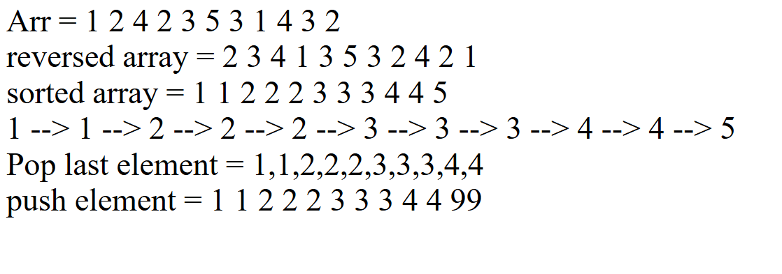

6.7 Exercise 6: Write JavaScript to use arrays methods e.g. reverse, concat, sort, join.

HTML:

<!DOCTYPE html>
<html lang="en">
<head>
<meta charset="UTF-8">
<meta name="viewport" content="width=device-width, initial-scale=1.0">
<title>Document</title>
</head>
<body>
<script>
let n = Number(prompt("Enter no of elements : "));
let a = [];
for(let i = 0;i<n;i++){
let num = Number(prompt("Enter element : "));
console.log(typeof(num))
a.push(num);
}
document.writeln("Sorted in ascending order = ");
a.sort(Number);
for(let i=0;i<n;i++){
document.writeln(a[i], " ");
}
document.writeln("<br>Sorted in descending order = ");
a.reverse();
for(let i=0;i<n;i++){
document.writeln(a[i], " ");
}
</script>
</body>
</html>

OUTPUT:

